What & How to Visualize Tsunami Damage in our drill

Pick your island and Look up your address at: https://tsunami.coast.noaa.gov/#/
This is my approximate location. I could walk down the street to get close to the Extreme Tsunami Zone and visualize the damage: [arrow shows where I could stand]

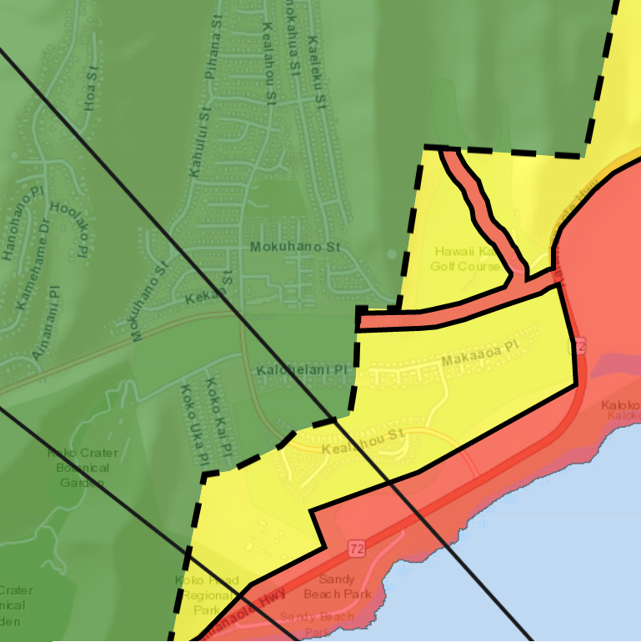

Now I could establish the location [Lat / Long] and make up my own inject:

“Just South of Kalohelani Pl. on Kealahou St. [21.2925, -157.6726]
Water, sand, debris and cars are blocking Kealahou. Makai of that point, many homes in Queen’s Gate and Laulima were totally destroyed by the wave. 10 - 12 people are injured ,wandering around, needing first aid. Unable to proceed past this area because of the damage.”

Based on the visualization above I could submit a Hawaii Damage Report:
“This is an exercise message.
Just South of Kalohelani Pl. on Kealahou St. [21.2925, -157.6726]
Water, sand, debris and cars are blocking Kealahou. Makai of that point many homes in Queen’s Gate and Laulima were totally destroyed by the wave.
This is an exercise message.”
And submit a Hawaii Request for Assistance:
“ This is an exercise message.
Just South of Kalohelani Pl. on Kealahou St. [21.2925, -157.6726] 10 - 12 people are injured ,wandering around, needing first aid. Please send an ambulance ASAP. We will set up a Medical Treatment Area with CERT members until they arrive.
This is an exercise message.”

