FORM 309
General Instructions for completing the form: [see form snapshots on page 3]

# Field Title Instructions
1 Incident Name / # Enter the name and activation number assigned to the incident,e.g., Kai a Pele (Drill)
2 Operational Period Enter the time interval for which the form applies. Record the start and end date and time, e.g., 10/24/2026 0900 10/24/2022 1200; for EOCs end time will be 1230
3 Net / Position Name For NCSs: Enter the name of the radio net
For Others: Enter the name of the position or tactical call
4 Radio Operator Enter the name and call sign of the radio operator (you)
5 Comms Log Time: Enter the local time in 24-hour format
From: Enter the From call sign or ID and the message number ¹
To: Enter the To call sign or ID and the message number ¹
Message: Enter the message Note 2
6 Prepared By Enter the name and call sign of the person completing the log
7 Date & Time Prepared Enter the date and time the form was prepared (24-hour clock)
8 Page numbers Enter the page number and number of pages

Note 0: Winlink ICS-309 Log does not have an area for message numbers.
Note 1: The message number is selected by the station originating the message and it must be on all messages. It stays with the message all the way to the point of delivery. The delivering station may need to reply to the station of origin and refer to this number. Use number digits only, no letters, leading zeros, or dashes. Numbers are usually begun with 1 at the start of a year or month at the pleasure of the originating station. The From message from one person may be #1. The message sent by the Hub may be #14.

Note 2: The call sign of the amateur station originating (creating) the message for first introduction into the amateur system is the station of origin and must be included in the subject line on all messages. This call sign must stay with the message to the point of delivery.

Note 3: Submit this form to your DEC at the end of your shift

Subject line should contain the following:

Originating station Call Sign | Message # | “Exercise” | Priority | Message Type | Location
NOTE: Above guidance pertains more to manually done ICS-309. Winlink ICS-309 will be done automatically and will not have a message number. Also the Winlink Field Situation Report does not include the call sign of the message originator in the subject nor have any message numbers.

Remember that the 309 is designed to indicate all messages received by you and all messages sent by you, not all messages heard by you but not directed to you.

Example Scenario 1:
KH6YO sends a voice message (their #1) for a damage report to WH6FLO (Hub).
WH6FLO transcribes the message into a Winlink Damage Report Message with subject line: KH6YO #1 Exercise R Damage Report Moiliili
Of course, the message body has all the information reported by KH6YO.

Note 4: It is customary to indicate within the text of such messages the word “EXERCISE”. Using “EXERCISE” as the first and last groups of the text helps alert listeners to the nature of the content to avoid undue alarm. For VOICE communications terms like “Simulated Damage” may also be appropriate.

Note 5: In the case of the new HI Damage Report and HI RFA [Request for Assistance] the term Exercise is automatically indicated on the form title and at the bottom of the message if EXERCISE is selected (automatically defaults to this).

Manual ICS-309 Paper Log Snapshot:
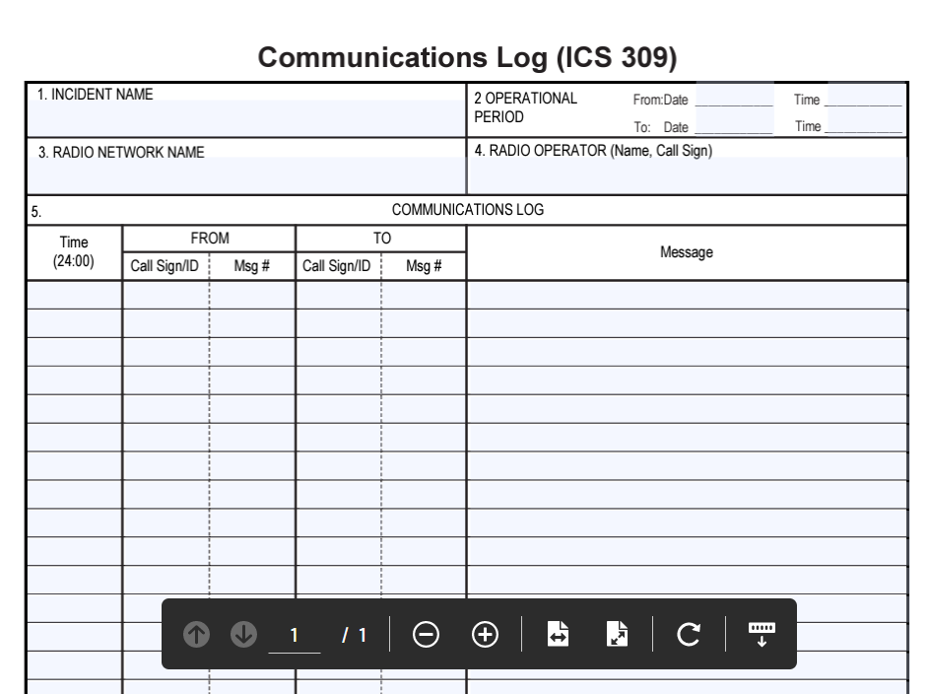

Winlink ICS-309 Snapshot:
